STAFF REPORT

Mount Dora Police Department
Police Communication Services
May 7, 2012



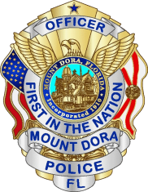

Chief of Police
T. Randall Scoggins

Prepared by:
Deputy Chief Ronald W. Rauth
Lieutenant Bruce W. Clark

Discussion:

In 2008 the United States entered a severe economic recession that caused state and local governments to suffer unprecedented declines in revenues. Mount Dora has experienced a similar erosion of income. As a result, the City of Mount Dora has systematically examined every service it provides to seek cost savings and to ensure our residents receive the most cost effective and efficient operations possible while maintaining a superior level of service.

Recently the subject of consolidation, or outsourcing, of public safety communications services (commonly referred to as police dispatch) has become more common. Examples of this can be seen locally and throughout the state. As Mount Dora struggles to meet its budget, “consolidation” has become a topic of discussion and speculation as a potential source of budget savings to the citizens of Mount Dora. The Mount Dora City Council has directed staff to research the subject and prepare a report.

Public Safety communications is a complex endeavor with far reaching implications for the agencies involved as well as for the everyday lives of the citizens within the jurisdiction. It is no longer a simple matter of answering the phone and radioing a police officer. A police department communications unit is often considered the nerve center of the agency and the city. Bristling with computers, technology, and responsibilities that were unimaginable just a few years ago; the modern communications center provides the city, its officers, and the community it serves with a huge array of services. Of course, the core mission of providing residents with an immediate and direct link to their first responders, as well as a 24/7 access point for general government, remains the highest priorities.

A police department communication unit not only provides its internal customers (police department employees) with a wide array of services but it also provides external customers (residents and visitors) with a broad range of services. Some services are immediately recognizable but many are not as readily apparent. This report will review as many as feasible.

The consolidation of services is not a new concept for law enforcement. Police administrators routinely evaluate how and where shared services are the most cost effective. In these chaotic financial times, the challenge is especially acute as Mount Dora has struggled with reductions in both personnel and budget.

The Mount Dora Police Department regularly works closely with our regional law enforcement partners (federal, state, and local) to address problems that are not cost effective to work independently. Wherever and whenever it makes sense, we join forces to accomplish our mutual goals. We work hard to sustain services at the same level our community expects and we seek every opportunity to accomplish our mission in the most cost-effective method possible.

Public Safety Communication Centers:

The public safety profession recognizes that there are four options for communications centers. They are:

- Maintain current services
- Outsource to a third party
- Consolidate among municipalities
- Consolidate as a region

Consolidation is a term often used interchangeably for what is really outsourcing. Outsourcing is merely contracting with an outside entity for a service. Consolidation means joining efforts into a unified/joint operation. Although the terms are commonly misused as synonyms, they have very different definitions and outcomes.

Regardless of the term used, every option has been examined by the Mount Dora Police Department staff and will be presented. The strengths and weaknesses of each alternative have been reviewed and potential directions for the future offered.

Mount Dora Police Communications Unit

To facilitate a comprehensive understanding of the Mount Dora Communications Center and provide for a thorough comparison of public safety communication options, we have begun the staff evaluation with a complete overview of the Mount Dora Communications Unit through its five major components:
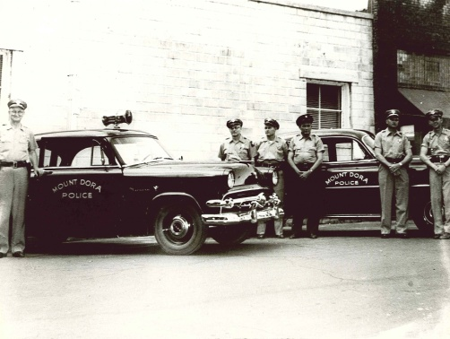
- Personnel
- Facility
- Technology
- Services
- Budget

Brief History:

Mount Dora Police Department has operated a communications unit throughout its entire history. Citizens wishing to contact the police or fire departments for emergency and non-emergency requests for service could call the department on telephone lines staffed twenty four hours a day, seven days a week.
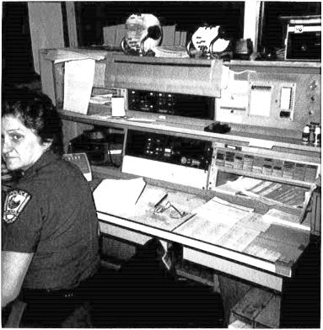
Prior to 2000 the communications office was staffed with a single dispatcher using a combination of full and part-time employees that were primarily non-sworn civilians. Police officers would commonly supplement staffing as needed.

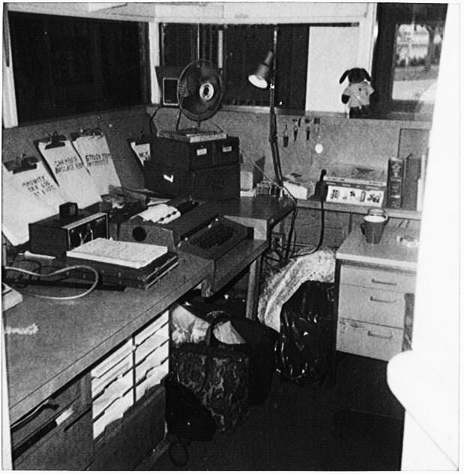

The Communications Unit was located in the Police Department in a small office dedicated for that use. Technology was limited to telephones, typewriter, a teletype machine and a radio. The dispatcher used a single radio console. There was no interoperability with other agencies other than the sheriff.

The office was situated so that the on-duty dispatcher also was always available to greet the public as they entered the police station.

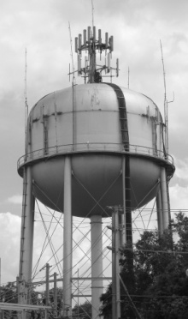
Up to the 1980s the radio system was a city-owned, stand-alone system with its own low band VHF frequency. The transmitter antenna was attached to the police station on 3rd Avenue. In 1988 the city switched to high band VHF and relocated the antenna to the water tower. It was powered by a single 1980s analog repeater. In 1988 Mount Dora also became part of the Lake County 911 system.

In the 1990s USA software was acquired for computer aided dispatch (CAD), report writing, and records management.

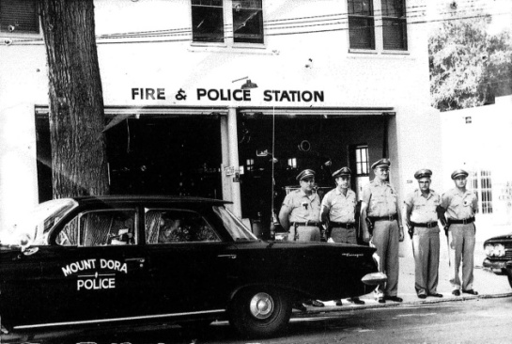
In 2000 the department began a modernization process to upgrade the technology and capability of communications to meet the growing needs of the city. For the next several years various improvements were made that included adding two digital radio consoles and improved software. However the basic backbone of the radio transmitter system still relied on the 1980 analog repeater with back-up from a 1970 repeater given to the police department by Orange County.

As the city continued to grow and calls for service increased, staffing was increased to eight full-time employees in 2001 so that two dispatchers would be on duty at any given time. Mount Dora also uses a part-time “on-call” dispatcher.

In 2004 The Mount Dora Police Department was awarded state accreditation by the Commission Florida for Law Enforcement Accreditation. Of the 273 state standards met by the department, many are requirements involving communications.

- Restricted access for security purposes,
- Procedures for handling calls received through text telephone(s) (TTY) or Telecommunications Relay Services (TRS),
- Continuous recording of radio transmissions and emergency telephone conversations,
- Immediate playback of radio and emergency telephone conversations,
- Procedures for handling and forwarding misdirected emergency calls and hang-up emergency calls,
- Procedures for obtaining information appropriate for the type of call received,
- Immediate access to the following resources, at a minimum:
  - Officer in charge
  - Duty rosters
  - Home telephone numbers of every member
  - Telephone numbers of emergency service agencies and
  - Visual depictions of the agency’s current service area
- Procedures for procuring external services such as ambulance, fire department, aircraft, and wreckers,
- Immediate access to all tactical dispatching plans,
- Procedures for radio communications to and from field members, to include:
  - Specification of the circumstances requiring radio communications by members
  - Documentation of initial status and any change in status
  - Methods used for identifying members during radio transmissions
  - Communication with interacting agencies
  - Criteria for the assignment of the number of members in response to an incident and
  - Guidelines for verifying member status after an established period of time has elapsed without contact,
- Security measures for the protection of communications members, facility, and equipment,
- Emergency power generator to ensure continued power to the Communications Center in the event of power failure,
- Procedures for obtaining interpretation services for non-English speakers,
- Sight and sound monitoring of holding cells for prisoner security and safety.

In 2006 the police department completed a major expansion and renovation project. The communications center was a key part of the design and improvements in order to ensure it could continue providing service to Mount Dora for many years. A complete discussion of the improvements is included in greater detail further into this document.

In 2007 the computer operating software for the department was significantly upgraded and enhanced with greater capabilities. A key component of the improvements included upgraded computer aided dispatch (CAD) software, improved report writing, and high speed wireless communications with our mobile computer terminals (MCTs). It was developed to include improved integration with our records management system (RMS) and to meet the Department of Highway Safety and Motor Vehicles (DHSMV) electronic reporting requirements for vehicle crashes. The new software also improved the effectiveness of the MCTs in all of our police and code enforcement vehicles. Currently all of our communication functions, records management system, and mobile computers in the field are fully integrated.

In 2009 Mount Dora became part of the new county-wide public safety radio system. This system includes interoperability for Lake County’s police, fire, and emergency medical service radio systems. For the first time, Mount Dora, as well as all Lake County cities, were completely integrated into a state-of-the-art radio system. Mount Dora communications was equipped with all new digital technology and equipment enabling it to dispatch and function at the highest standards. The 700/800 MHz trunking technology is part of a nationwide system that allows interoperable communications between local, state, and national public safety entities.

Finally, in 2010 the Mount Dora Police Department worked closely with the Motorola Company to reengineer our radio “consoles” to enhance their information gathering, channel grouping, and display capabilities. The Mount Dora prototype was so far advanced from the original design that the Motorola Company planned to market our version to other cities.

Part 1: Personnel

As we know, the most important component of any organization is the people that make it function. The Mount Dora Communications Unit operates at a very high level of effectiveness because of the exceptional quality of its personnel. Their training, dedication, experience, and maturity have helped distinguish the unit as one of the most professional in Central Florida.

Support Services Division


The Mount Dora Communications Unit is in the Support Services Division under the command of Lieutenant Bruce W. Clark.
- 22 year veteran of law enforcement
- 27 years administrative experience
- Doctoral degree
- Multiple awards, MDPD as well as outside agencies
- Florida Accreditation Manager of the Year
- 2011 Lifetime Achievement Award from the
American Society of Industrial Safety Professionals
- State Certified Law Enforcement Instructor - General subjects and firearms

Mount Dora Communications Officers

Mount Dora dispatchers bring a depth of experience to the job and share a close connection with the community. Our dispatchers have an institutional knowledge of the city, they are informed on city events, they know the geography, the police officers, other city employees, and many of the citizens and business owners. Dispatchers learn the locations and people with chronic medical conditions, mental disorders, frequent complaints, and high risk suspects.

The dispatcher’s knowledge of the city, landmarks, recurring problems, priorities, department policy and procedures, and city ordinances often helps minimize problems and provides our police officers with a resource they would not otherwise have.

Mount Dora Communication Officers have:
- Cumulative experience of 107 years
- Average experience of 13 years

Paula Anscomb   | - 7 years experience (Mount Dora)  - CTEP Trainer  - State Certified Telecommunications Officer  - Certified FCIC/NCIC/DAVID  - Communications Training Officer
Sheila Baker   | - 24 years police officer, current reserve officer  - 34 years dispatcher experience (Tavares and Mount Dora)  - 12 years dispatcher Mount Dora  - State Certified Telecommunications Officer  - Specialized training: FTO, SRO, THI  - Mount Dora resident 24 years
Sandra Bryan   | - 7 years dispatcher experience (Mount Dora)  - 32 year career in United States Navy  - Retired Command Master Chief  - Education/Training: Graduate of University of Maryland, Graduate of Seina Heights College, Attended University of Michigan Graduate Program, Graduate of the US Naval War College, Recruit Company Commander, qualified Military Corrections Officer  - State Certified Telecommunications Officer  - Mount Dora property owner
Karan Campbell   | - 10 years dispatcher experience (Fire and Mount Dora)  - Education/training: Critical Incident Stress Management, Fire Safety classes, Code Enforcement, Medical, Firefighter 1 course, IS100 & IS700 NIMS classes,  - Certified FCIC/NCIC/DAVID  - State Certified Telecommunications Officer
Bonnie Clark-Davis   | - 15 years dispatcher experience (Tavares and Mount Dora)  - Education/Training: Firefighter/first responder, CPR, APCO/CTO, 911 certified,  - FCIC/NCICDAVID certified.  - Communications Training Officer  - State Certified Telecommunications Officer  - Mount Dora resident for 28 years
Sharon Kemp   | - Lead Dispatcher  - 27 years total dispatcher experience (Lake County Sheriff’s Office, Sumter County, Clermont, Cocoa)  - 11 years experience in Mount Dora  - Education/Training: , Georgia Police Academy 911 Dispatcher graduate, APCO, 911, LAI,  - Communications Training Officer  - FCIC/NCIC/DAVID certified
Heather Morris   | - 6 years dispatcher experience (1 year Orlando International Airport, 5 years in Mount Dora)  - Emergency Medical Dispatch certified  - CPR  - FCIC/NCIC/DAVID certified  - State Certified Telecommunications Officer
Jennifer Vaughn  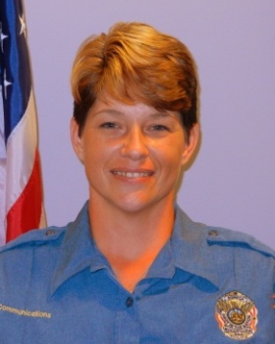 | - Newest dispatcher  - Hired 2011 (Mount Dora)  - FCIC/NCIC/DAVID certified  - 4 years commercial dispatch experience

Part 2: Facility

Mount Dora Police and Fire Headquarters Building –

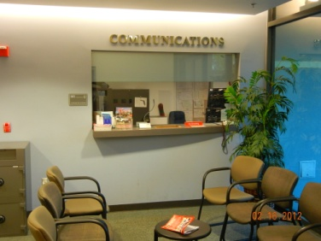
The Communications Unit is located on the ground floor of the Police Department in a space specially designed and built for that purpose. The design allows for the full array of traditional public safety communication services but also facilitates an enormous range of other services as well as providing for the critically important 24/7 public access from the lobby of the police department.

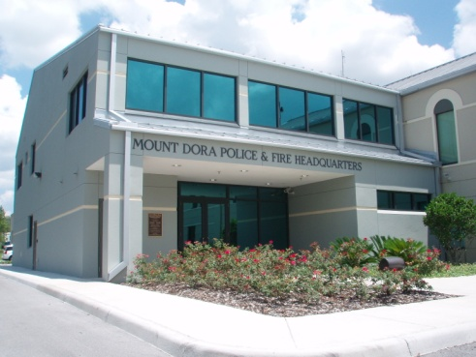
The Mount Dora Police and Fire Headquarters Building was substantially renovated and expanded in 2006. The four million dollar project provided additional space and dramatically improved safety and effectiveness for police operations. A major goal of the project was to build a totally self-contained communications center that would serve well for many years. The new design and construction enabled the entire building to meet the much higher standards resulting from the terrorist attacks of 2001 and the hurricanes of 2004.

Some of the key features of the Mount Dora Communications Unit include:
- Building designed and built to meet higher standards for man-made and natural disaster threats. It is hardened throughout.
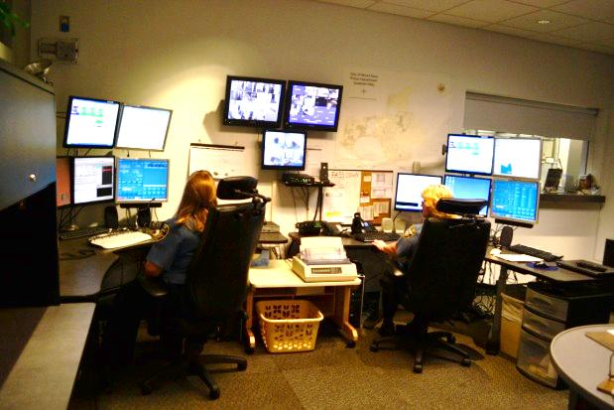
- Communications space designed specifically “ground up” as a communications unit.
  - Poured concrete envelope
  - Steel doors
  - Ballistic glass
  - Additional air purification to facilitate 24/7 operations
- Redundant Power Systems
  - Main generator
  - UPS battery back-up
  - Back-up rapid connection to outside generator
- Designed for easy public access for after-hours customer service
- Communications Unit Security
  - Secured within a secure facility
  - Totally self-contained facilities: bathroom, lockers, kitchen
Part 3: Technology

The Mount Dora Communications Unit is fully equipped with up-to-date technology for every function performed. The only technological needs anticipated for the future will come through normal technology advancements.

- 911 PSAP (Public Safety Access Point)
  - 911 center for police, fire, and medical emergencies
  - Equipment is new
  - 911 funds help pay for all 911 related expenses including:
    - Phone service
    - Data software
    - Computers
    - Back-up power system
    - Furniture
    - Equipment
    - Training
  - Radio system
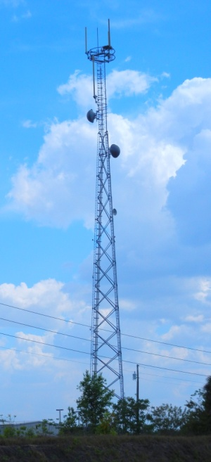
    - County-wide 700/800 MHz based Motorola trunking system
      - 18 tower sites providing near 100% coverage
      - Lake County is responsible for all maintenance, upkeep, and computer system upgrades
    - Full compatibility and interoperability: local, state, and national
    - Every officer issued a portable radio
    - Every vehicle equipped with a mounted radio
    - Mount Dora is assigned 10 talk groups (channels)
    - “Patching” capabilities
    - Two dispatch work stations
  - Specially designed furniture for 911 PSAP’s
  - Able to accommodate additional staff during disaster operations
  - Centrally located near the City Emergency Operations Center (EOC) at the Police and Fire Headquarters Building
  - Specially designed computer room flooring so that all electrical and other cabling is under the floor
  - Secure computer equipment room with its own HVAC system
  - NCIC/FCIS/DAVID Computers
  - Computer Aided Dispatch software
  - Fully integrated reporting and records management software
  - Secure closet where all building security equipment is housed
  - Additional interior security door in case of building breach
  - Recording capabilities for all internal and external camera systems

Part 4: Services Provided

The Mount Dora Communications Unit provides many direct and indirect services to Mount Dora residents, visitors, and other city departments.

Traditional Police Dispatch Services

- Answer all 911 calls, police, fire, medical
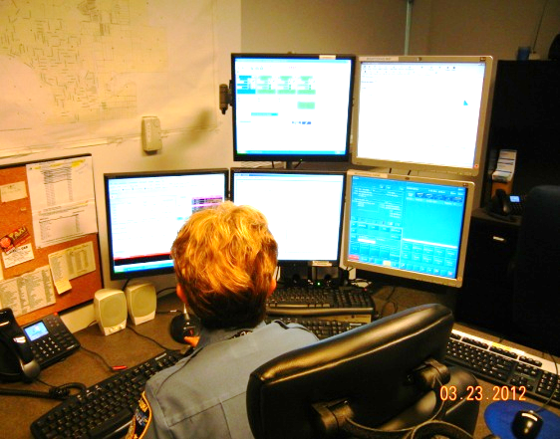
  - 2000 –3600 per year
  - 2011 –5500 per year
- Answer 6 non-emergency phone lines
  - 26,000 – external inbound
  - 8,000 - outbound
  - 7,300 - internal inbound
- Calls for service dispatched
  - 2000 –17,500 per year
  - 2010 –25,000 calls per year
  - 2011 – 29,226 including:
  - 5000-6000 officer-initiated traffic stops
  - 1000s of officer well-being checks
  - Assorted critical functions:
  - FCIC/NCIC and local data bases for warrants and advisories
  - DAVID for driver license status
  - DHSMV for vehicle tags
  - Activations of Silver and Amber Alerts
  - Administrative assistance to patrol officers: phone calls, notifications, warrant confirmations, checking maps, etc.
  - FCIC/NCIC entry of stolen/lost property including vehicles and firearms
  - Tracking repossessions and tow logs
  - Emergency notifications including: detectives, traffic homicide investigators, chaplains, chain of command personnel, command staff, and evidence technicians

Additional Comprehensive Responsibilities of MDPD Communications

- Administrative assistance to patrol officers: report research, phone calls, notifications, location verifications, copying, faxing, building maintenance, etc.
- Tracking false alarm calls
- Noise ordinance warning and citation records
- Trespass warnings and violation log
- Filing injunctions, trespass warnings, and garage sale permits
- Safety refuge
  - Domestic violence, (see Attachment 1 on 2004 Ocala Police Station murder)
  - “Safeplace” infant drop
- Help desk and city switchboard, 24/7, weekends, holidays, etc.
  - Access to Police and Fire Department personnel
  - Routine community inquiries and questions
  - Special event questions
  - Visitor information
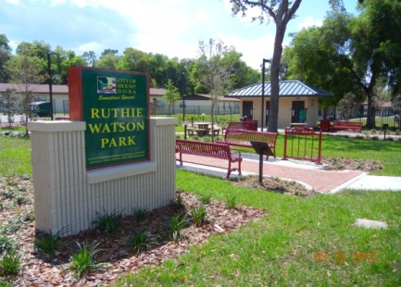
  - Directions
  - Storm information
  - Traffic and street closures
  - Senior citizen outreach
  - Ruthie Watson Park video monitoring
  - City building alarm monitoring
    - Library
    - City Hall
    - City annex
    - Community Building
    - Property/Evidence building
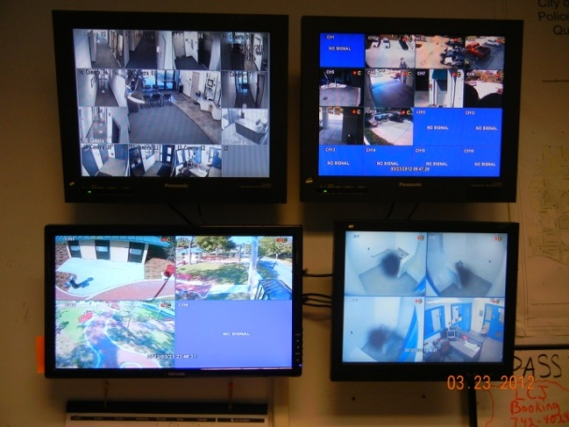
    - Martin Luther King Center
    - CareHere
    - Donnelly Park building
  - Police Building Security
    - Video monitoring of entire building and parking lots
    - Computer controlled building access system
    - all outside doors
    - critical inside doors
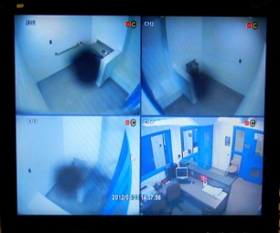
    - Remote controlled prisoner Sallyport gates
    - Holding cell prisoner monitoring (see Attachment 2 on Daytona Beach holding cell hanging)
    - Booking area employee security (see Attachment 3 on Alabama police station murders)
- Walk-in service
  - 2000 citizen walk-ins per year
- Parks and recreation facility sign-out and return of keys
- Utility payments and weekend turn-on service
- Utility trouble reporting and weekend dispatching - 24/7
- Rapid data capturing and retrieval through CAD including:
  - 911 call retrieval
  - Routine complaint information
  - Patrol activity
  - Call and Crime patterns
  - Response time analysis
  - Complaint Call retrieval
  - Traffic stop profiling data
- Extra watch coordination (for residents on vacation, out of town, etc.)
- Lost and found coordination, (pets are common)
- Bicycle Registration coordination (common on weekends, significantly increases during holidays)
- Animal control complaints
- Special event personnel monitoring and CJIS services provision

Part 5: Budget

Mount Dora Police Department Communications Budgets 2007- 2011
2007 | 2008 | 2009 | 2010 | 2011
364,513 | 345,498 | 390,791 | 394,600 | 399,300

Option II - Outsource to a Third Party

An option to accomplish any governmental service is to simply contract the function out to another department. For Mount Dora there appears to be two principal options for outsourcing communication operations:

- The Lake County Sheriff’s Office
- Another municipality

However, in addition to the aforementioned agencies, a complete outsourcing analysis would need to include proposals from other agencies such as Orange County, Seminole County, Apopka and other Lake County cities.

For the purpose of this report, a Request for Proposal (RFP) was limited to the Lake County Sheriff’s Office. Their proposal will be discussed in detail later.

Comparable Agencies:

The staff examined four other area cities that have outsourced their communication operations or are currently operating a communications unit similar to Mount Dora.

City 1: Tavares Police Department:

In 2001 the City of Tavares Police Department outsourced their communications operations to the Lake County Sheriff’s Office in order to save money. When Tavares closed their dispatch, no one was assigned to staff the Police Station after business hours and there was no city phone number after hours for residents to call. The lobby was left unlocked so residents and crime victims could come in and pick up a phone that connected them to the Sheriff’s dispatchers.

After several years, Tavares became aware that the level of service provided by the county’s communication unit was less than they were receiving when they operated their own center. The service needs of Tavares appeared to exceed what the Sheriff’s Office Communications customarily provided.

In 2005 a Tavares council member found a distraught victim of domestic violence in the parking lot of their city hall. She went to the police station for help and only found the phone that connected her to the Sheriff’s Office dispatchers. The council member stayed with the victim until a Tavares police officer arrived almost 10 minutes after the call was made. It was later learned that there was a delay in dispatching the call.

In 2006, the Tavares city council grew increasingly concerned of the lack of staffing at the police station/city hall and voted unanimously to reinstate their own communications office. Their goal was to:

  - Improve the level of services for all residents
  - Improve the safety and efficiency of the Police Officers
  - Improve the communications for other city departments
  - Improve security for city buildings and infrastructure
  - Allow residents to obtain help from city hall at all times

In 2010 Tavares assessed the rebuilding of their communication office:

“Since the reimplementation of the Communications Center, the Police Department has dramatically improved its response time, accountability, officer safety, and greater citizen access.”

Currently Tavares continues to operate their own communications unit which is comparable to Mount Dora. They employ eight (8) fulltime and several on call part time dispatchers to ensure two (2) are on duty at all times.

Tavares Police Department Communications Budgets
2007- 2011
2007 | 2008 | 2009 | 2010 | 2011
690,824 | 573,160 | 556,286 | 496,385 | 468,234

City 2: Maitland Police Department:

In the mid-1990s the Maitland Police Department outsourced their communications center to the City of Apopka to save money. Chief of Police Ed Doyle reported that Maitland’s communication center needed a 2.4 million dollar renovation and technology update. 1.2 million dollars was needed immediately and 1.2 million dollars was needed several years later. Maitland instead chose to outsource. They considered the Orlando Police Department, the Orange County Sheriff’s Office and the Apopka Police Department as providers. Apopka was the low bidder and assured Maitland they would provide “same” services. Chief Doyle believes their commitment was honest and genuine.

Chief Doyle retired in 2003, eight years after outsourcing his communications center and after nearly 30 years in law enforcement. He said his decision to close his communications center was the “worst mistake” he made during his career. “To this day, I am ashamed that our level of service to those counting on it was diminished”. He said the loss of services to the residents of Maitland was enormous. The Apopka Communications Center, despite their good intentions, simply could not provide the level of service that the Maitland communications center routinely provided their residents.

Chief Doyle further cautioned that the citizens and businesses will be the ones who “pay the price” for outsourcing. “Maitland is still living with this well-intended bad decision”. He cited the lack of local knowledge, loss of identity, impersonal service, miscommunication, and delays in responsiveness as recurring problems. In retrospect, he said Maitland would have been better served by finding the money to bring their communications center up to acceptable standards.

Presently the Maitland Police Department locks its doors after business hours. A call box is maintained outside and is linked to the Apopka communications center. There is no direct phone number for residents to call anyone in city government after hours.

The Maitland Police Department currently reports that the Apopka Communications Operation is providing professional service. However, Maitland is still struggling with the organizational and structural limitations of a third party providing communication services. Current Maitland Chief of Police, and former Winter Park Chief of Police, Doug Ball reports:

- There is a “tremendous” loss of service to their residents
- No one staffs the police department after business hours
- The Apopka dispatch has little to no local knowledge of Maitland
- The CAD system of Apopka is totally incompatible with Maitland’s reporting and records management software. There is no integration or interface.
- Because of the software difference, there is a potential for:
    - loss of information
    - reporting inefficiency
    - increased liability through miscommunication

The cost for Maitland to update their reporting and records management software to match Apopka’s CAD system is currently prohibitive. The cost, time, and staff effort to integrate the two systems will be enormous.

Chief Ball described a recent complaint he took from a very angry, elderly resident who has lived in Maitland for many years. She recently called “the city” with a problem and was very upset that the dispatcher did not even know that her address was in the city. She did not understand that when she called Maitland it was answered by someone in Apopka. Deputy Chief of Police Bill McEachnie said that every week he handles some sort of problem or complaint from an unhappy resident that called the Maitland Police Department and instead got someone from Apopka.

The Maitland Police Department would like to re-instate their own communications operation. However the cost to do so at this time is prohibitive.

Maitland Budget:

Maitland Police Department Communications Contract
2011-2015
2011 | 2012 | 2013 | 2014 | 2015
372,475 | 393,000 | 414,600 | 437,400 | 461,400

Maitland’s contract has an automatic 5.5% increase each year.

City 3: Clermont:

In 2010 the City of Clermont outsourced their communications operations to the Lake County Sheriff’s Office. They reported their communications center was underperforming and believed they could save money by shedding the service. They agreed to a five year contract at $396,426 per year. Each year either party may request to renegotiate the cost. Clermont terminated their 11 dispatch employees.

Clermont also incurred other costs to outsource to the Sheriff’s Office. They paid the Sheriff’s Office $102,713 for dispatch equipment and furniture. To match the Sheriff’s software operating system they had to buy new software (Spillman) for an additional $310,600. That did not include the cost to convert their records system from New World software to Spillman. Consequently, Clermont is currently using three different software operating systems to access archived records: USA, New World, and now Spillman.

Clermont locks the door to their police department at 6:30 pm. They do not staff anyone at the police station after hours. A call box wired to the Sheriff’s dispatch center is maintained outside. The Sheriff did not hire any of the terminated Clermont dispatchers.

Clermont outsourcing costs:
- $396,426 (annual for salaries and benefits)
- $102,713 one-time payment for equipment
- $19,626 annual payment for equipment
- $310,600 for software change
- $34,825 annual maintenance for software
- Cost to maintain 3 records management systems (unreported)
- Employee accrual pay outs (unreported)
- Unemployment expenses (unreported)

First year costs: $809,739 + unreported
Recurring yearly expense: $450,877

City 4: Eustis Police Department:

The City of Eustis operates a communications unit very similar to Mount Dora and Tavares. They employ eight (8) full-time dispatchers plus part-time dispatchers with the goal of maintaining two on duty at all times.

Eustis’s lobby is open 24/7. Eustis dispatchers monitor their public lobby and booking area via video camera. In the event of a critical incident in their lobby, Eustis dispatchers can electronically allow entry of a threatened person into a safety refuge area.

Chief Cobb reports that Eustis dispatchers provide great value to the community and his officers by their knowledge of the city and of the potential dangers of known problems. They provide so many services that he described them as “force multipliers” of his sworn staff.

The Eustis Police Department has researched the possibility of outsourcing their communications to the Lake County Sheriff’s Office. They have determined that the loss of service and control far outweigh any potential savings they may realize from outsourcing. They plan to maintain their communications operation for all of the reasons that caused Tavares to rebuild theirs.

Eustis Police Department Communications Budgets
2007- 2011
2007 | 2008 | 2009 | 2010 | 2011
417,967 | 437,276 | 440,427 | 467,242 | 479,998

Summary of Cities with Communications provided by the Lake County Sheriff’s Office

Clermont $450,877
Tavares (2001-2006) $186,000
Tavares (2010 proposal) $247,766 + $141,635 equip. (5 dispatchers) Howey-in-the-Hills No cost
Umatilla No cost
Astatula No Cost
Fruitland Park No cost
Mascotte No Cost
Minneola No cost

Communication Officers Pay Comparisons

The largest and most costly component common to all communication operations is in personnel costs. The following allows a quick reference for these expenses.

Mount Dora Communication Officers Salary
- Entry pay $25,753
- Top pay $33,310
- Average pay $29,466

Tavares Communication Officers Salary
- Entry pay $26,250
- Top pay $45,750
- Average pay $35,360

Eustis Communication Officers Salary
- Entry pay $26,598
- Top pay $37,544
- Average pay $30,815
Lake County Sheriff’s Office Communications Unit
- Call Taker $21,964
- Teletype operator $24,377
- Entry pay dispatcher $27,060
- Top pay dispatcher $40,073

Groveland Police Department
- Entry Pay $27,768
- Top Pay $41,329

Leesburg Police Department
- Entry Pay $26,603
- Top Pay $39,478

Lady Lake Police Department
- Entry Pay $27,081
- Top Pay $40,705

City of Apopka
- Entry Pay $35,235
- Top Pay $55,161

Mount Dora Communications - Approximate Cost to Outsource:

The Lake County Sheriff’s Office submitted a request for proposal (RFP) to provide the Mount Dora Police Department with communication services. They provided the following:

LCSO proposal:
- $349,657 annual contract
- $102,713 one-time payment for equipment
- $10,626 annual payment for equipment

Mount Dora transition expenses:
- $310,600 for software change
- $34,825 annual maintenance for software
- $9,600 overtime expenses for training employees on new software
- $50,000 - $100,000 (est.) for records conversion to new software
- $12,677 Severance pay
- $37,810 Accrual pay outs,(comp, vacation, sick time)
- $0 - $173,800 Liability for unemployment expenses

First year expense: $918,508
- Liabilities
  - Additional Software conversion $ 50,000
  - Unemployment $ 173,800

Potential total first year expense $1,142,308

Recurring annual costs: $360,283

Cost to Replace Other Services:

Additional staff for police station to stay open 24/7:
- Duplicate monitoring equipment in dispatch office in records office,
  - $10,000 - $20,000 (approx.)
- Hire three (3) new employees @ $27,000 salary each, plus benefits
- $110,000 annual

Five (5) City Comparison

Tavares, Maitland, and Clermont outsourced their communications to save money. Five years later, Tavares resumed communication services. Mount Dora and Eustis have not outsourced. All five agencies currently incur approximately the same cost for communications when adjusted for individual agency budgeting and organizational structures.

Fiscal Year 2012:

Tavares $468,234
Maitland $393.000
Clermont $450,887
Mount Dora $399,600
Eustis $479,998

Outsourcing Advantages:

Outsourcing may provide a long term operating budget savings if a corresponding reduction in the level of service is acceptable. Limiting communication services to only traditional emergency 911 and non-emergency dispatching costs less to provide than a full range of services.

Outsourcing Disadvantages:

Outsourcing will require a very large initial outlay in transition costs and will result in a severe reduction in services unless additional staff is hired to compensate.

- Increased cost to replace lost staffing
- Reduced services to residents, police officers, other city departments
  - No building alarm monitoring
  - No building video monitoring
  - No park monitoring
- Loss of direct control over quality and performance
- Safety compromised for arrestees, visitors, and employees in the Police Building
- Increased liability due to potential miscommunication
- Loss of control over future operating budgets
- Loss of control for cost of software and technology upgrades by dispatching agency
- Nearly irrevocable decision without incurring enormous start-up costs including:
  - infrastructure and equipment
  - personnel recruiting and training
  - organizational knowledge and experience

Outsourcing Conclusion:

Outsourcing Mount Dora’s Communication Unit is a viable option if the structural limitations of contracted services are acceptable. Our research has indicated that the City of Apopka and the Lake County Sheriff’s Office both provide professional law enforcement communication services on a contractual basis. However, that service is narrowly limited to emergency 911 and non-emergency communications; services that are commonly thought of as traditional police dispatching. Neither agency provides the wide array of services to residents that are typically delivered by municipalities operating their own communications unit.

By strictly limiting the scope of services to what is normally considered “traditional police dispatching” a contracted provider can be expected to provide that service at a lower expense than a full service communications center. That is accomplished primarily through economies of scale: i.e. reduce the number of dispatchers directly servicing an agency by pooling personnel and have them responsible for more officers and multiple agencies.

Cost Benefit Analysis:

The expenses of the key components for Mount Dora to operate a communications unit are similar, if not lower, compared to the outside providers studied. There are no distinguishing differences in costs for personnel, facilities, technology, and services. Neither Apopka nor LCSO do anything cheaper or more efficiently than Mount Dora.

Mount Dora delivers an enormous amount of services to its community in a remarkably cost efficient and effective operation. Mount Dora may well have the lowest cost communications center for any city of comparable size and character in all of Central Florida.

None of the agencies that have outsourced their communication operations have reported that the overall service to their residents has improved.

Option III – Consolidation with Other Municipalities:

Consolidation with another municipality(s) such as Tavares and Eustis could be a viable option. In this scenario an organization would be created with a governing board comprised of representatives of the three police departments. The board would set policy, budget, and management structure. All three cities would share an equal voice in all of the critical issues.

A municipal consolidated dispatch offers some important advantages over outsourcing but it also still has some significant weaknesses. The initial attractiveness of consolidation is similar to outsourcing: economy of scale in regards to the traditional dispatching functions. However, unlike outsourcing to a third party, the participating agencies would maintain control over quality, accountability, and operational costs.

The disadvantages are still significant and the loss of services by each participating agency would have to be reconciled. Moreover, the initial investment in infrastructure would be very large and any savings would take years to realize.

Consolidation Challenges:

- Finding city(s) to participate
- Creating a new legal entity
- Establishing governing bylaws
- Naming a governing board
- Determining management oversight
- Building a Facility
- Purchasing all equipment
- Settling on operating software
- Determining scope of services
- Staffing
- Developing rules, policy and procedures, protocols
- Transition costs

Advantages:
- Economy of Scale
- Control
  - Budget
  - Policies and procedures
  - Services provided
  - Personnel
  - Quality
  - Responsiveness
  - Accountability

Weaknesses:
- Consolidation Costs:
  - Legal expenses of creating an entity, agreements, etc.
  - Liability, indemnities, insurance, etc.
  - Establishing a Governing Board
  - Building a Facility
  - Hardware expenses
  - Software conversion and expenses
- Loss of police station staffing
- Loss of individual jurisdiction services

Option IV – Regional Consolidation:

Regional consolidation would offer all of the benefits of local consolidation and potentially greater economy of scale. The Lake County Sheriff’s Office currently provides police dispatch service to seven cities: Mascotte, Minneola, Clermont, Fruitland Park, Astatula, Howey-in-the-Hills, and Umatilla.

Groveland, Eustis, Mount Dora, Tavares, Leesburg, and Lady Lake maintain their own Communication Units.

In a regional consolidation configuration all of the public safety agencies in Lake County (police, fire, and emergency medical) would form an authority or consortium and jointly operate communications. The Lake County Sheriff’s Office would merely be a one of the members.

The new Lake County Public Safety Communications Office would be an independent agency governed by a board comprised of representatives from every public safety agency. Every department, jurisdiction, and city would maintain an interest in the most effective and cost efficient operation possible. Policy and procedures, operating software, staffing, and protocols would all be standardized.

Funding options could be provided by the Lake County government much like the new radio system. Or the funding formula could be proportional to a city’s population and would be a matter to be determined at the time the charter is agreed upon. Future budgets would be determined by the governing board.

Regional Consolidation Challenges:

- Creating a new legal entity
- Establishing governing bylaws
- Naming a governing board
- Determining management oversight
- Building a Facility
- Purchasing all equipment
- Settling on operating software
- Determining scope of services
- Staffing
- Developing rules, policy and procedures, protocols
- Transition costs

Advantages:
- Economy of Scale
- Control
  - Budget
  - Policies and procedures
  - Services provided
  - Personnel
  - Quality
  - Responsiveness
  - Accountability

Weaknesses:
- Consolidation Costs:
  - Legal expenses of creating an entity, agreements, etc.
  - Liability, indemnities, insurance, etc.
  - Establishing a Governing Board
  - Building a Facility
  - Hardware expenses
  - Software conversion and expenses
- Loss of police station staffing
- Loss of individual jurisdiction services

As the benefits and liabilities of outsourcing and consolidation are weighed and deliberated, we are reminded of the most significant principle of the entire discussion in a recent article in The Police Chief, March 2012 magazine.

Charles J. Kocher, EdD, Deputy Chief of Police (Retired), Camden, New Jersey in “Sustaining Police Operations” at an Efficient and Effective Level under Difficult Economic Times, asks the key question,

“In the final analysis, will shared services or consolidation of law enforcement services actually enhance the delivery of efficient and effective operations to better serve the community, or will services become watered down and impersonal?”

Attachment 1
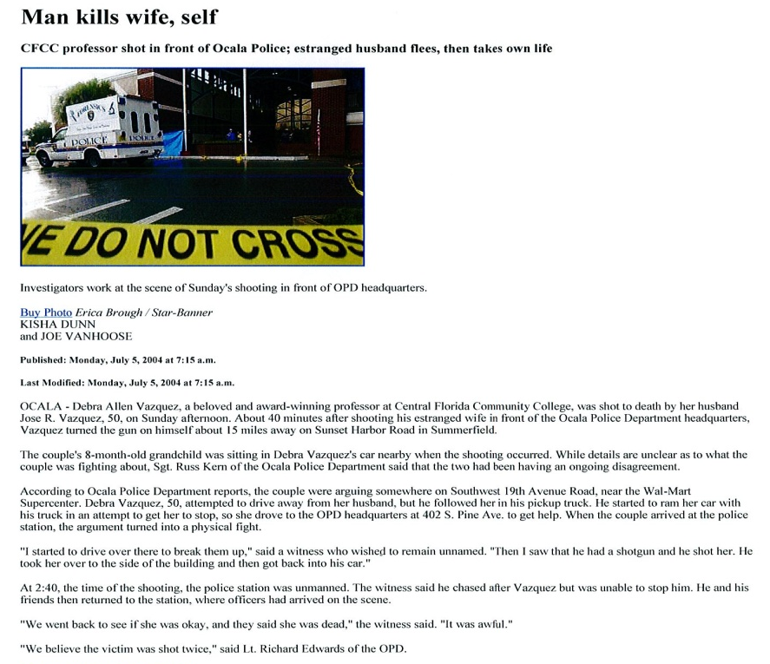
Ocala Police Station Murder
Attachment 2

Daytona Beach Shores Holding Cell Hanging

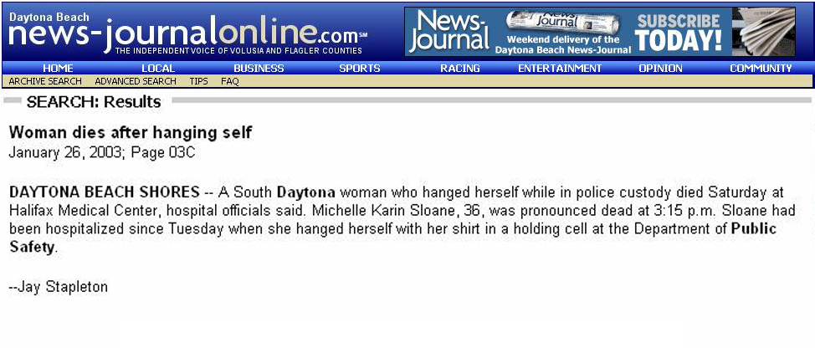
Attachment 3

Alabama Police/Fire Station Murders
