 |  | 53rd Annual Training Conference
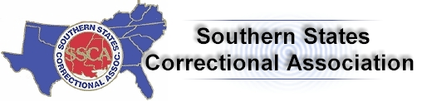43rd Annual Training Conference | In conjunction with the
“Kentucky: Down the Stretch to Success”
July 15-17, 2012

Griffin Gate Marriot Resort and Spa, Lexington, Kentucky
Reservations: 800-266-9432 or https://resweb.passkey.com/go/SSCAJuly
Advance Registration due by July 1, 2012

Please Print or Type:

Name:_________________________________________________________________
FIRST MIDDLE INITIAL LAST

Title:_____________________ Agency/Facility:______________________________

Business Address:_______________________________________________________

City:_______________ State:________ Zip:__________ Phone:__________________

Email Address:__________________________________________________________

Is this your first SSCA conference? Yes No

Advance Registration (Prior to July 1st) $150.00 $_______
Late/On-Site Registration (After July 1st) $170.00 $_______
SSCA Membership Dues $25.00 $_______
KCCD Membership Dues $15.00 $_______
Golf Tournament $65.00 $_______

Additional Tickets or Spouse/Guest Registration for Special Events

No._____ President’s Reception (Sunday) $60.00 $_______
No._____ Kentucky Night (Monday) $55.00 $_______
No._____ SSCA Awards Banquet (Tuesday Evening) $50.00 $_______

No._____ KY Department of Corrections Luncheon (Monday) $25.00 $_______
(KY DOC Luncheon not included in Conference Registration)

Total Registration $_______
Checks should be made payable to: SSCA 2012

Send completed forms and payment to: Jamie Strang
3001 West Hwy 146
LaGrange, KY 40032

Any questions should be directed to Jamie Strang, Conference Registration Coordinator, by email at jamier.strang@ky.gov or 502-222-9441, extension 4015.

NO REFUNDS TWO WEEKS PRIOR TO CONFERENCE DATE

Please contact Dale Hazelwood at 502-750-1284 or by email at Dale.Hazelwood@ky.gov for transportation to and/or from the airport, by July 1, 2012.

Arrival Date:________________ Time:___________ Airline & Flight #:____________

Departure Date:_____________ Time:___________ Airline & Flight #:____________

