

**FLORIDA MODEL JAIL STANDARDS**

**COMMITTEE MEETING**

***Special Hotel Rate***

***gd***

**Thursday, March 14, 2019**

**\*\* $98.00 Standard Room** King or Queen**

Via Telephone Direct: (352) 753-7535 (24 hours)

Via Telephone Toll Free: (800) 592-0774 (24 hours)

**Ask for the Sumter County Sheriff’s Office Special Rate**

**Reservations must be made by:**

**Friday, February 22nd 2019**

**Provide ID at check in**

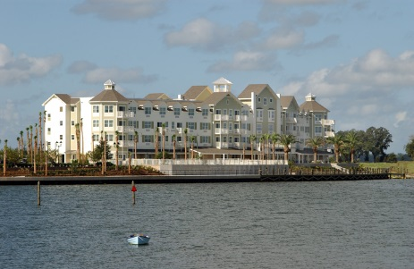

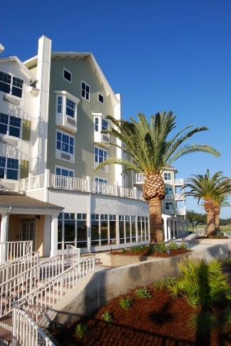

**GUEST ROOM AMENITIES**

• Pillow top King and Queen

beds with luxury linens

• Flat Screen TV’s with Premium cable

Channels

• Complimentary High speed Internet

• Refrigerator, microwave, and

Keurig coffee makers with K-Cups

• Iron, ironing board, hair dryer

Receive a 20% discount with ID in our signature restaurant, Amelia’s! Casual dining open 7 days a week serving breakfast, lunch, & dinner.

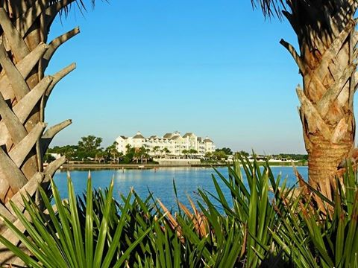

***1105 Lakeshore Drive The Villages, Florida 32162***